**Fishers High School Clubs & Extracurricular Activities**

***Listings as of July 2023***

FHS is committed to engaging all students inside and outside of the classroom, and it is our goal to provide an opportunity for each student to connect to the school outside of the school day. All student participants must follow the FHS Student Handbook at all times. Below you will find a list of our current club offerings, as well as communication methods and club sponsor(s). Please contact the sponsor directly with questions about a club.

2000s FUN

**Sponsor(s):** Erin Knapp, [eknapp@hse.k12.in.us](mailto:eknapp@hse.k12.in.us)

**Description:** This is a throwback to childhood – with little-to-no technology. We’re going to play board games, do crafts, work on puzzles, and use sidewalk chalk to create a stress-free environment for students to gather and socialize for fun! The goal is social interaction and creating a sense of belonging at FHS.

**Club Meeting Info**: We will meet twice a month, after school (3:00 to 4:00pm) .. See the schedule here: <https://docs.google.com/spreadsheets/d/194ocGBWvLEfPE0F081XlKtvpQtYOmXx6bCR65DDsF4E/edit?usp=sharing>

3D PRINTING CLUB

**Sponsor(s):** Renee Isom, [risom@hse.k12.in.us](mailto:risom@hse.k12.in.us)

**Description:** We will meet to plan and execute 3D printing projects using the equipment in the media center. We will also fundraise to afford more printing materials. Open to everyone, regardless of experience!

**Club Meeting Info**: TBD

ACADEMIC AMBUSH TEAM

**Sponsor(s):** Alex Smith, [alsmith@hse.k12.in.us](mailto:alsmith@hse.k12.in.us); Katie Hagerty, [khagerty@hse.k12.in.us](mailto:khagerty@hse.k12.in.us)

**Description:** The Academic Ambush is comprised of three teams: Quiz Bowl, Spell Bowl, and Academic Super Bowl. Quiz Bowl is a team-based, Jeopardy-like trivia competition. Spell Bowl is a team-based spelling bee. Academic Super Bowl is a multidisciplinary team competition unified by them. See Mr. Smith or Ms. Hagerty for information on all three!

**Membership Requirements:** $20 membership dues

**Club Meeting Info**: Spell Bowl meets every Monday after school in A135. Quiz Bowl meets every Monday after school in A117. Academic Super Bowl will begin in the Spring.

AMERICAN SIGN LANGUAGE (ASL) CLUB

**Sponsor(s):** Angela V. Farrand, [afarrand@hse.k12.in.us](mailto:afarrand@hse.k12.in.us)

**Description:** ASL Club members will expand their knowledge of ASL and Deaf culture through ASL related activities and by attending events for the Deaf in our local community.

**Membership Requirements:** Active participation and a desire to learn more about ASL and the Deaf Community.

**Membership Fees** : You will be asked to purchase one ASL Club t-shirt. Additional fees will vary depending on the cost of events we attend.

**Club Meeting Info**: Meetings will be the 1st and 3rd Tuesday of each month from 3:05 pm to 4:05pm

ANIMAL ALLIANCE

**Sponsor(s):** Tammie Spencer, [tspencer@hse.k12.in.us](mailto:tspencer@hse.k12.in.us)

**Description:** If you are an animal lover, then this club is for you! Animal Alliance is a club that gives students the opportunity to make a difference in our community by helping animals. Club members 16 years or older will be eligible for volunteering at the Hamilton County Humane Society once a month for a couple of hours. Members under 16 will have the opportunity to design projects that bring awareness to the help that animals in our community need.

**Membership Requirements:** Open to all

**Club Meeting Info**: Call out meeting will be held in B212 on August 28th, 3:00 - 4:00 pm.

**Social Media:** Instagram:@fishers_animal_alliance Remind: Text @fhsanimala to 81010

ANIMATION CLUB

**Sponsor(s):** Glenn Seland, [gseland@hse.k12.in.us](mailto:gseland@hse.k12.in.us)

**Description:** The Animation Club will allow students to explore different animation mediums and learn about the different aspects of animation production. We will initially start with learning how to animate, but in the end, we hope to create a 3-5 minute animated short film to submit to the All-American High School Film Festival in early March 2023.

**Club Meeting Info**: Mondays, 3:00 - 4:00 PM

ARAB ASSOCIATION

**Sponsor(s):** Chris Edwards, [cedwards@hse.k12.in.us](mailto:cedwards@hse.k12.in.us)

**Description:** This club is open to anyone with an interest in Arab culture or connecting with Arab people. Our hope is to create a sense of belonging for all students and create an opportunity for new friendships.

**Membership Requirements:** Open to anyone

**Club Meeting Info**: Every Thursday, beginning September 9. Meet in B211.

ART CLUB

Sponsor(s): Lisa Brown, [lgbrown@hse.k12.in.us](mailto:lgbrown@hse.k12.in.us)

Description: TBD

Membership Requirements: TBD

Club Meeting Info: TBD

ASIAN STUDENT UNION

**Sponsor(s):** Scott Black, [sdblack@hse.k12.in.us](mailto:sdblack@hse.k12.in.us)

**Description:** TBD

**Social Media:** TBD

**Membership Requirements:** TBD

**Club Meeting Info**: TBD

AURA8 DANCE CLUB

**Sponsor(s):** Taylor Meador, [tmeador@hse.k12.in.us](mailto:tmeador@hse.k12.in.us)

**Description:** If you love K-pop and also love to dance, Aura8 is a great space for you! Whether you have 10 years of dance experience or only one month, you can join this club1 We’re here to learn and have fun while preparing to showcase our talent.

**Social Media:** Instagram- @aura8danceteam / Remind - @kdancefhs

**Membership Requirements:** Have a flexible schedule; $10 club fee (will be used for outfits, performance, etc.)

**Club Meeting Info**: Every Wednesday from 3:00 to 5:00 pm (room TBD)

BEST BUDDIES

**Sponsor(s):** Lauren Wilson, [lnwilson@hse.k12.in.us](mailto:lnwilson@hse.k12.in.us)

**Description:** FHS’ Best Buddies Program is all about the inclusion of people with disabilities in all aspects of society. We strive to increase students’ understanding and comfort level around people with disabilities. We hope to develop lifelong friendships, social supports, opportunities, and resources for people with disabilities.

**Social Media:** TBD

**Membership Requirements:** Must be open-minded, kind, considerate, accepting of others, and willing to put in the time to develop long-term relationships with students who have disabilities.

BIBLE STUDY GROUP

**Sponsor(s):** Jacob Kapitan, [jkapitan@hse.k12.in.us](mailto:jkapitan@hse.k12.in.us)

**Description:** In this club, we will go through various books the Bible using a set of guiding questions to help understand what they are saying. We will reflect on the questions individually before discussing as a group to help each other create a shared understanding. We will try to incorporate games and multimedia elements whenever possible!

**Social Media:** TBD

**Club Meeting Info**: Every other Thursday at 7:45 AM

**Membership Requirements:** None! Just show up with an open mind and a copy of the Bible (or digital access on your device)

BIKING CLUB

**Sponsor(s):** Kristin Marr

**Description:** TBD

**Social Media:** TBD

**Club Meeting Info**: TBD

**Membership Requirements:** TBD

[BRING CHANGE TO MIND](https://www.youtube.com/watch?v=eCQcm3OyrmQ&feature=emb_logo) ([video here](https://www.youtube.com/watch?v=eCQcm3OyrmQ&feature=emb_logo))

**Sponsor(s):** TBD

**Description**: Bring Change to Mind’s High School Program gives teens a platform to share their voices and raise awareness around ***mental health***. Our goal is to empower students to educate one another and to foster a culture of peer support about mental health at FHS. The club organizes thematic monthly meetings or community outreach, maintains the Wellness Room in Guidance, and plans and staffs the student-run event, Hope for Happiness, which occurs every May in the Nickel Plate District.

**Social Media:** IG: @bc2m_fishers Remind: text bc2m_fhs to 81010; Website: <https://bringchange2mind.org/>

**Membership Requirements**: All high school students, no matter their relationship to or knowledge of mental illness, are welcome to join the BC2M Student Movement. Attend monthly meetings; Leadership Team attends an additional meeting each month for planning

**Club Meeting Info**: TBD

CHAMPIONS TOGETHER CLUB

**Sponsor(s):** Patrick Schooley, [pschooley@hse.k12.in.us](mailto:pschooley@hse.k12.in.us)

**Description:** Champions Together Club will promote servant leadership among student athletes by engaging the whole school to provide & promote unified sports activities, competitions and clinics. Teams include Unified Bocce, Unified Flag Football, Unified Track & Field and Unified Bowling. Also included is basketball and kickball. The goal is to have representatives from each varsity athletic team and performing arts on planning committees.

**Social Media:** Twitter - @FhsTogether / Remind: text @fhschamp to 81010

**Membership Requirements:** Participants include general education students, unified sports athletes and varsity athlete volunteers from our IHSAA / athletic programs.

**Club Meeting Info**: TBD

CHEMISTRY CLUB

**Sponsor(s):** Lance Kuhn, [lkuhn@hse.k12.in.us](mailto:lkuhn@hse.k12.in.us)

**Description:** Come join us for a variety of fun science demos and labs that ordinarily would not be covered in Chemistry classes. We will also have guest speakers in September and November. We’re just getting started, so come join us and help the club grow!

**Social Media:** Instagram @fhschemclub / Remind: <https://www.remind.com/join/fhschem24>

**Membership Requirements:** Interest in chemistry.

**Club Meeting Info**: First semester: Call-out Aug. 23; Sept. 26 during TI; Oct. 25 before school; Nov. 14 during TI; Dec. 6 before school

CHESS CLUB

**Sponsor(s):** Brigham French, [bfrench@hse.k12.in.us](mailto:bfrench@hse.k12.in.us)

**Description:** Chess club is a place to learn the basics of the game in a friendly environment and a place to play competitively with other students.

**Social Media:** Remind: @fc2ba8

**Membership Requirements:** TBD

**Club Meeting Info**: Every other Tuesday (Next Meeting Sept 5th)

CLUB MED / HOSA (“Health Occupations Students of America”)

**Sponsor(s):** Sarah Walker, [swalker@hse.k12.in.us](mailto:swalker@hse.k12.in.us)

**Description:** HOSA is a club that explores a wide range of occupations to give students a broad view of the medical community. We also try to give students some experience with medicine, by having a variety of speakers each year and a couple of field trips to relevant sites in the city (ex. The Medical Academic Center for a cadaver lab, Medical History Museum, etc.)

**Social Media:** Remind - @223dk89

**Membership Requirements:** $20 membership dues

**Club Meeting Info**: Wednesdays at 7:45am in A217 (Note: we do not meet every Wed)

COMPUTER SCIENCE CLUB

**Sponsor(s):** Ryan Harris, [rharris@hse.k12.in.us](mailto:rharris@hse.k12.in.us)

**Description:** Computer Science Club is a forum for students interested in computer programming, hardware, software, or other CS topics to connect with students who have similar interests and learn from each other.

**Social Media:** TBD

**Club Meeting Info:** TBD

CONRAD CHALLENGE

**Sponsor(s):** Dan Mach, [dmach@hse.k12.in.us](mailto:dmach@hse.k12.in.us)

**Description:** The Conrad Challenge is a year-long entrepreneurial and innovation-focused competition where students work in teams of 2-5 to formulate a solution, in the form of a product or service, to a societal issue of their choice. If students’ ideas are promising enough and qualify for later rounds of the challenge, they can travel to Houston to compete against teams across the globe, pitching their idea to a panel of judges, which can earn them impactful scholarships and allow them to engage in the true entrepreneurial process.

**Social Media:** TBD

**Club Meeting Info:** TBD

CREATING ACTION THROUGH SERVICE (C.A.T.S.)

**Sponsor(s):** Renee Vanlandingham, [rvanlandingham@hse.k12.in.us](mailto:rvanlandingham@hse.k12.in.us)

**Description:** CATS is a student-led service club focused on developing resources and in-classroom activities for teachers, as well as creating service day camps for the HSE e-Learning day. K-4th grade students attend to learn foundational information for service-based learning and complete their own service projects.

**Membership Requirements:** Membership fee $10 (to purchase supplies for e-Learning Day camp service projects)

**Social Media:** Instagram- @fhscreatingactionthruservice Email- catshse@gmail.com

**Club Meeting Info**: Callout meeting will be on Thursday 08/24/2023, all other meetings will be Monday at 7:45am, Mz. Vanlandingham room (B236)

CROCHET CLUB

**Sponsor(s):** Heather Ferguson, [hferguson@hse.k12.in.us](mailto:hferguson@hse.k12.in.us)

**Description:** All are welcome at Crochet club! We meet in the mornings to talk, meet new friends, and crochet. We teach beginners how to crochet and make little squares to form blankets, which we eventually donate to a local organization in need. The club provides crochet hooks and yarn. Great opportunity to meet people and de-stress!

**Membership Requirements:** Membership fee (to purchase supplies)

**Club Meeting Info**: Every other Friday @ 7:30 AM in H212

CROSSFIT CLUB

**Sponsor(s):** Scott Patterson, [spatterson@hse.k12.in.us](mailto:spatterson@hse.k12.in.us)

**Description:** Ever wanted to get in better shape and feel great? All students are welcome to join, no matter your skill level. You will be taught the different lifts and movements. We do a variety of workouts, some with weights, some without. All workouts can be modified to fit your ability. If you have any questions, please email or stop by my room (A207) anytime.

**Membership Requirements:** None

**Club Meeting Info**: Monday, Tuesday, and Thursday, 3:30-4:30 in the old weight room between FH6 and FH7.

CRU

**Sponsor(s):** Tammy Snyder, [tsnyder@hse.k12.in.us](mailto:tsnyder@hse.k12.in.us)

**Description:** Everyone is on a spiritual journey, and Cru is here to help you on yours. Cru is a Christian-based organization where students come together and spend time learning more about faith, no matter what your spiritual background is. Follow us on Instagram as we keep you connected with our meetings and sign up for text updates to let us know if you are interested in joining our club and to get our text updates. [www.cruindy.com](http://www.cruindy.com)

**Social Media:** [Instagram - @crufishershse](https://www.instagram.com/crufishershse/)

**Membership Requirements:** None, just show up!

**Club Meeting Info**: Monday Nights, 7:17pm - 8:45pm in the CCA starting Aug 21st

CULTURAL CONNECTIONS CLUB

**Sponsor(s):** Renee Isom, [risom@hse.k12.in.us](mailto:risom@hse.k12.in.us)

**Description:** Our club focuses on learning about various cultures present at Fishers High School. We work together in groups to create presentations demonstrating traditional games, dances, and other aspects of a chosen country’s culture. We also share what we learn about celebrations and enjoy food together. Our long-term goal is to host an international fair at Fishers High School and in the meantime we learn, share, and have fun. Students can join at anytime, even if you missed the call-out meeting!

**Social Media:** Instagram @fishers.ccc / Remind @fhs-ccc

**Membership Requirements:** Welcome to all :)

DANCE TEAM

**Sponsor(s):** Katy Liddell, [fishersdanceteam@gmail.com](mailto:fishersdanceteam@gmail.com) 

**Description:** The official competitive and performance based team representing Fishers High School. It is our mission to show pride in our team by upholding tradition, honoring teammates, and committing to make this an exemplary program each year. We strive to be an example to others by promoting community service and leadership within the town of Fishers. As a competitive team, we will compete as part of the Indiana High School Dance Team Association (IHSDTA) and perform at various school sporting events and functions (football, basketball, spirit events, etc.). We will work to push and support each other to reach higher expectations than previous years and above all recognize that this team is not built by one person alone but by the group as a whole.

**Social Media:** Facebook: Fishers Dance Team

Instagram: @fishersdanceteam

Twitter: @FishersDanceTe1

**Membership Requirements:** Team tryouts are held in the spring and team members are selected based on a variety of criteria (technique, performance quality, positive attitude, work ethic, etc.). Members are required to attend all practices and performances to perform. Members are also required to pay monthly team dues to cover the costs of costumes, team uniforms, camps, music, competition entry fees, etc. All team finances will be covered in detail at call-out meetings and can be found in our team handbook. Team members will incur additional costs for individual practice attire and solo/ensemble fees throughout the season.

**Team Practice & Try-Out Info**: Call-Out Meetings will be held in the spring and our multiple-day Try-Out will be held in April/early May. Tryout registration information will become available in the spring on all social media platforms. Team practices Tuesday/Thursday 6:00-9:00 PM at FHS in June-March with additional team conditionings and weekend performances/competitions.

DECA

**Sponsor(s):** Braden Tribolet ([btribolet@hse.k12.in.us](mailto:btribolet@hse.k12.in.us)) and Jeremy Guler ([jguler@hse.k12.in.us](mailto:jguler@hse.k12.in.us))

**Description: DECA** prepares emerging leaders and entrepreneurs in marketing, finance, hospitality, and management in high schools and colleges around the globe. There are many ways to be involved with DECA for the social aspects, networking, leadership, scholarship opportunities, competition (district, state and international), community service, etc...

**Social Media:** Twitter - @fishersdeca / Instagram: fishersdeca

**Membership Requirements:** Membership Fee for 2023-2024 is $40

**Club Meeting Info**: Call-Out Meeting: Wednesday, September 14th at 7:30 am in Cafe A

DESI (INDIAN) STUDENT ASSOCIATION

**Sponsor(s):** Ryan Harris, [rharris@hse.k12.in.us](mailto:rharris@hse.k12.in.us)

**Description:** TBD.

**Social Media:** TBD

**Membership Requirements:** TBD

**Club Meeting Info**: TBD

DISNEY CLUB

**Sponsor(s):** Kristin Marr, [kmarr@hse.k12.in.us](mailto:kmarr@hse.k12.in.us)

**Description:** Love everything Disney? Want a fun club to join? Just want to hang out and play games, do trivia, and watch movies? Disney Club is the club for you! We play Disney-themed games, engage in Disney trivia, play/take Disney-themed quizzes, watch Disney movies, read scripts from Disney movies, talk about Disney, and even sing Disney karaoke!

**Membership Requirements:** None! Just show up!

**Social Media:** Remind code @2gadgg

**Club Meeting Info**: Call out meeting will be August 26 from 3:10 to 4:10 in the CCA

We meet Thursdays from 3:10 to 4:10pm. We meet in the CCA, except for the last Thursday of each month (we meet in B214 those days).

“DO SOMETHING” CLUB

**Sponsor(s):** Suzie Huppenthal, [shuppenthal@hse.k12.in.us](mailto:shuppenthal@hse.k12.in.us); club email [fishersdosomething@gmail.com](mailto:fishersdosomething@gmail.com)

**Description:** This club will be dedicated to the website <https://www.dosomething.org/us>. This organization provides many different opportunities for serving communities and provides action plans for seeing projects through. We will be doing our part to better the world. We will attempt to engage in a different campaign each meeting, with the goal of collecting donations for various causes. This club will be student-run (but supervised by a teacher).

**Membership Requirements:** None! Just show up!

**Social Media:** Instagram & Tiktok (@fhs.dosomething)

**Club Meeting Info**: Every other Wednesday after school (3:00 to 4:00pm)

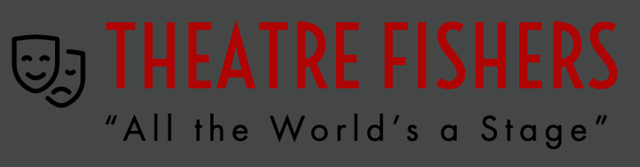

DRAMA CLUB

**Sponsors:** Emma Rund ([erund@hse.k12.in.us](mailto:erund@hse.k12.in.us)) and Andy Smith ([asmith@hse.k12.in.us](mailto:asmith@hse.k12.in.us))

**Description:** Drama Club is the organization for students who are involved or want to be involved in the extracurricular theatre program at FHS, whether onstage or behind-the-scenes. Drama Club helps support Theatre Fishers productions and meets independently of those rehearsals every other Friday from 3:05-4:00.

**Website: Click** [**www.theatre-fisher.com**](http://www.theatre-fisher.com) **for information on our program offerings AS WELL AS this year’s theatrical season!**

**Social Media:** Instagram-@theatrefishers (<https://www.instagram.com/theatrefishers/>)

**Membership Requirements:** Participation in the extracurricular theatre program (or a desire to!)

**Club Meeting Info**: CALLOUT MEETING for Drama Club is Aug 25th and 10th 3:00pm to 3:40pm in the Blackbox Theatre (G167).

DUNGEONS & DRAGONS CLUB

**Sponsor(s):** Steven Curtis, [scurtis@hse.k12.in.us](mailto:scurtis@hse.k12.in.us); Jacob Kapitan, [jkapitan@hse.k12.in.us](mailto:jkapitan@hse.k12.in.us)

**Description:** Adventurers Needed! All are welcome to join in on the fun, playing one of the most popular table-top role playing games. If you’ve never played, no problem! We would love to teach you how. If you are an experienced player, we are always in need of students to help DM and run a group through an adventure. We use 5th edition D&D materials. There is no requirement to purchase books since the basic rules for D&D play and character creation are available for free online.

**Social Media:** text the message @fhsdd to the number 81010

**Membership Requirements:** $3 annual membership fees to help the club purchase consumable materials and each member gets a set of dice with their dues.

**Club Meeting Info**: Club meets every other Tuesday after school until 4:30. Actual dates are available on the Dungeons and Dragons Club Canvas page.

E-SPORTS CLUB

**Sponsor(s):** Jacob Kapitan, [jkapitan@hse.k12.in.us](mailto:jkapitan@hse.k12.in.us)

**Description:** E-Sports Club is a place where you can connect and play with fellow students who take an interest in E-Sports. Join to find a team of friends to play in the competitive scene of whichever game you have an interest in or just join for casual gaming.

**Social Media:** Discord (join at the club meetings)

**Club Meeting Info**: TBD

ECONOMICS CLUB

**Sponsor(s):** Dave Turner, [dturner@hse.k12.in.us](mailto:dturner@hse.k12.in.us)

**Description:** Members of the economics club meet to learn economics beyond what is taught in the classroom and to prepare for spring economics competitions.

**Social Media:** none

**Membership Requirements:** Credit in economics or current enrollment in economics is beneficial, but not a requirement.

**Club Meeting Info**: TBD

ENL TUTORING CLUB

**Sponsor(s):** Alisa Vaughn, [avaughn@hse.k12.in.us](mailto:avaughn@hse.k12.in.us)

**Description:** Math tutors will teach ENL students math in different languages in order to help students who need additional assistance. Subjects covered will include Algebra I, Algebra II, Geometry, and Pre-Calculus.

**Membership Requirements:** Members need to strong in math, passionate about helping other students succeed, and ideally be conversational in a language other than English.

**Club Meeting Info**: Thursdays, 3:00 to 4:00 PM

ENVIRONMENTAL MOVIE CLUB

**Sponsor(s):** Heather Ferguson, [hferguson@hse.k12.in.us](mailto:hferguson@hse.k12.in.us); Summer Noyes, [snoyes@hse.k12.in.us](mailto:snoyes@hse.k12.in.us)

**Description:** This club was inspired by the final exam in AP Environmental Science and is built on watching environmental-related movies (examples: *Finding Nemo, Blackfish*, etc.) and discussing the relationship and messages that can related to our world. We will build projects related to recycling or other environmental causes and discuss how we, as citizens, can contribute less to nature’s problems.

**Social Media:** TBD

**Membership Requirements:** TBD

**Club Meeting Info**: TBD

ETHICS BOWL & PHILOSOPHY CLUB

**Sponsor(s):** Chris Edwards, [cedwards@hse.k12.in.us](mailto:cedwards@hse.k12.in.us)

**Description:** Philosophy Club is centered around civil discussions about ethical problems and questions. Most of the club is spent preparing for the Ethics Bowl Competition at the Prindle Institute for Ethics at DePauw University in the beginning of the second semester; thus, the club is considered to the FHS Ethics Bowl team. Join the Hamilton Southeastern Ethics Bowl Team, as well. The Ethics Bowl will take place via Zoom on February 2nd 2021. Email Dr. Edwards at [cedwards@hse.k12.in.us](mailto:cedwards@hse.k12.in.us) with questions.

**Social Media:** Twitter - @fhsphilosophy / Instagram - @fhsphilosophy

**Club Meeting Info**: tbd

EUCHRE CLUB

**Sponsor(s):** Terri Thompson-Mejias, [tthompsonmejias@hse.12.in.us](mailto:tthompsonmejias@hse.12.in.us)

**Description:** Euchre Club is a great way to end the school week! If you like this traditional midwestern card game, this is the club for you. We meet every final RED day of the week. Everyone is welcome, from beginner to advanced players. Can’t wait to see you there!

**Membership Requirements:** None; just show up!

**Club Meeting Info**: We meet at the tables outside H205 at 7:30 a.m. on RED days. Check social media for dates..

Instagram: fhs_euchre_club Remind: Text FHSEuchre to 81010.

FELLOWSHIP OF CHRISTIAN ATHLETES (FCA)

**Sponsor(s):** Lauren Votaw, [lvotaw@hse.k12.in.us](mailto:lvotaw@hse.k12.in.us)

**Description:** F.C.A. is open to any student looking for fellowship with other students who enjoy sports through games, a devotional, and prayer. Donuts are always free!

**Social Media:** Twitter - @fishers_FCA / Instagram: Fishers_fca / Tik Tok Fishers_FCA

**Membership Requirements:** None; just show up!

**Club Meeting Info**: Kick-Off Meeting Wednesday, August 23rd at 7:45 AM in LGI. We will meet every Wednesday beginning August 23rd. FCA will not meet on October 18th, November 22nd or December 20th.

FHS READS! BOOK CLUB

**Sponsor(s):** Renee Isom, [risom@hse.k12.in.us](mailto:risom@hse.k12.in.us)

**Description:** A place where students can share their love of reading, participate in our state’s book award program, and promote titles for others to read. We have fun, play some games and of course, READ.

**Social Media:** Remind - text @readfhs to 81010

**Membership Requirements:** None; just show up!

**Club Meeting Info**: TBD



FILM CLUB

**Sponsor(s):** Glenn Seland, [gseland@hse.k12.in.us](mailto:gseland@hse.k12.in.us)

**Description:** Come to our club and you will *never* watch movies the same again! Go deeper into film ideas and think like a film critic...or just come and hang out! Film club is where students gather to watch movies from different eras and genres and discuss them in a relaxed, fun environment. While watching, we discuss all the interesting things the filmmakers were doing in creating the film. We want to know what the filmmaker wanted to tell the story in a specific way. Films are selected regularly by students and range from blockbuster films to classics. Films are all capped by a PG13 level rating.

**Social Media:** Remind - @fhsmovies

**Membership Requirements:** None

**Club Meeting Info**: TBD

FISHERS STEP CLUB

**Sponsor(s):** Rachael Allen, [rallen@hse.k12.in.us](mailto:rallen@hse.k12.in.us)

**Description: Stepping**,is a showcase for exhibiting individual style and teamwork. It’s a coordinated dancelike performance that blends African folk traditions with popular [culture](https://www.merriam-webster.com/dictionary/culture). The body is used to make sounds through clapping, stomping, vocal exchanges, and sharp movements.

**Social Media:** None

**Membership Requirements:** None; all steps are taught for everyone to learn

**Club Meeting Info**: TBD

FISHERS TUTORS

**Sponsor(s):** Kitti Gal, [kgal@hse.k12.in.us](mailto:kgal@hse.k12.in.us); Renée Vanlandingham, [rvanlandingham@hse.k12.in.us](mailto:rvanlandingham@hse.k12.in.us)

**Description:** Fishers Tutors is a group of students who want to help tutor students at Fishers Junior High and possibly the other two junior highs so they are ready for high school their freshman year. Anyone can join, but we are asking for students who are strong in a certain subject area. Subjects needed include math, English, social studies, and science. If you are interested, email a sponsor or Sharanya Srivastava, President of Fishers Tutors: srivasha[001@hsestudents.org](mailto:srivasan000@hsestudents.org) Note: This opportunity counts toward service hours! We especially need students to volunteer second semester.

**Social Media:** Remind: text @tutorsfhs to 81010

**Club Meeting Info**: We meet on Tuesdays at FHS for quick check-ins (3:00 - 3:30) as tutors; we will tutor junior high students on Thursdays (4:00 - 4:45 PM). [A full schedule of meetings can be viewed here](https://docs.google.com/spreadsheets/d/14khmXMjpDBWan95rlh5OJS1wY4ruHGbfMsq2zWCXf9s/edit?usp=sharing).

FISHING CLUB

**Sponsor(s):** Samuel Lawrence, [slawrence@hse.k12.in.us](mailto:slawrence@hse.k12.in.us)

**Description:** It’s always exciting when a fish is on the line. We will have fishing trips, tournaments and guest speakers for training and educating members. Members can share their catches on social media to stay informed of who is catching fish between activities.

**Social Media:** Instagram: @fishersfishingclub , Remind: @fishin1

**Membership Requirements:** All Skill Levels from beginner and fishing for fun to tournament participants.

**Club Meeting Info**: A calendar with dates will be given out at the first meeting or as requested by email.

FRENCH CLUB

**Sponsor(s):** Jessica Geisinger, [jgeisinger@hse.k12.in.us](mailto:jgeisinger@hse.k12.in.us) and Dahnya Chop [dchop@hse.k12.in.us](mailto:dchop@hse.k12.in.us)

**Description:** We meet to eat! Every meeting involves food. Some of our big events of the year are: a crêpe party, a murder mystery dinner, a French yule log cake party, a French cooking night, a fondue party, French breakfast and more.

**Social Media:** We have a Canvas page for French Club to which your name will be added once you become a member. Events will be announced via Canvas announcements and emails and also placed on the Canvas calendar.

**Membership Requirements:** You must be currently enrolled in French at FHS or have taken French previously at FHS.

**Club Meeting Info**: Pay dues to your French teacher. First meeting: Crêpe party on Sept. 6th!

FSN BROADCASTING (HS SPORTS NETWORK)

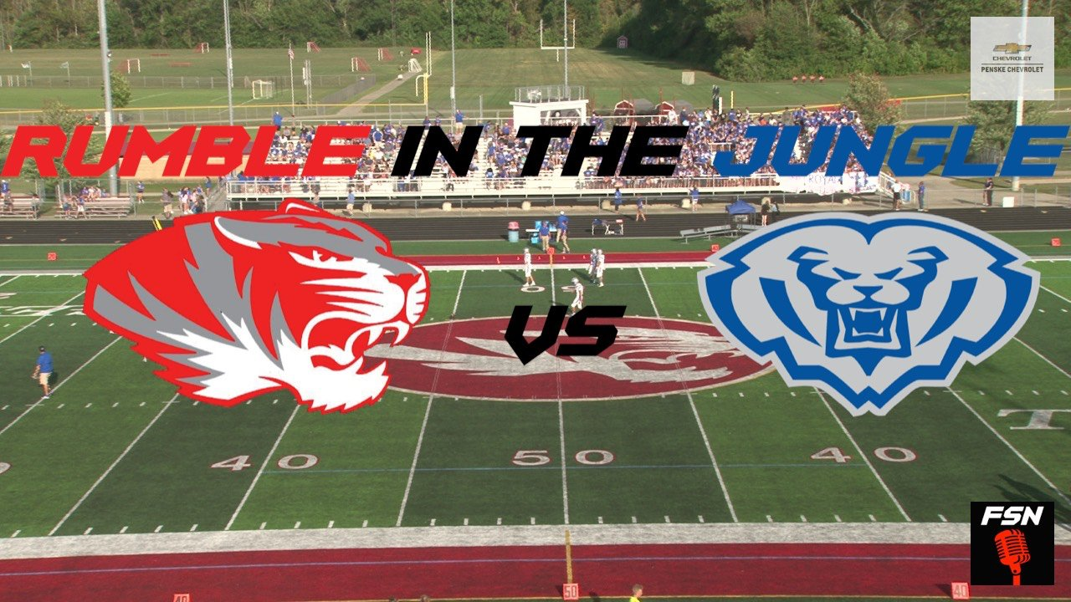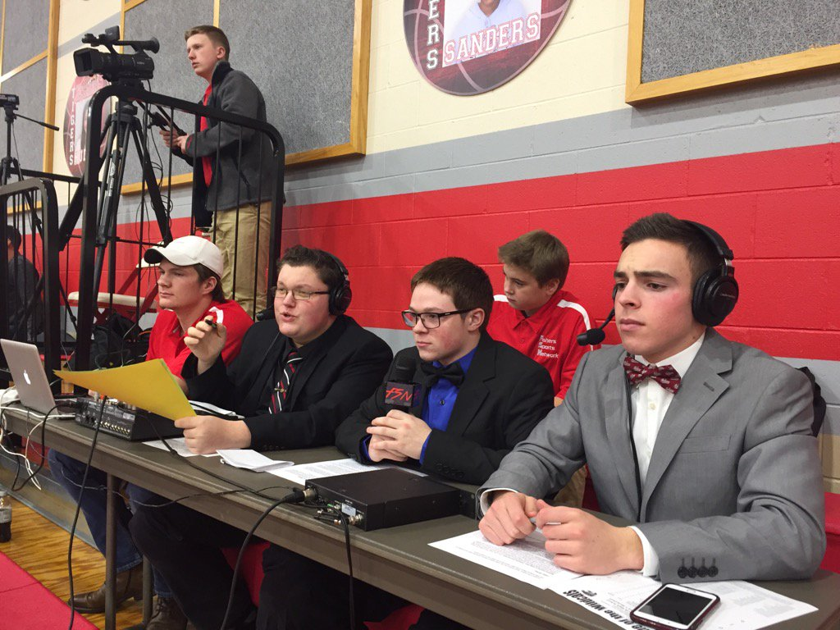

**Sponsor(s):** Paul Kennedy, [pkennedy@hse.k12.in.us](mailto:pkennedy@hse.k12.in.us); Michelle Greco, [mgreco@hse.k12.in.us](mailto:mgreco@hse.k12.in.us)

**Description:** FSN is our FHS sports network that does live streaming and broadcasting of select FHS sporting events. There are several different roles to be played within the organization including broadcasting, player/coach interviews, camera work, production and design, creative - social media, and more.

**Social Media:** Twitter - @FSN_Tigers; Instagram - @fsntigers; Facebook - Fishers Sports Network - FSN

**Membership Requirements:** Students can join the club at any time.

**Club Meeting Info**: Please e-mail sponsors for information to join the club!

FUTURE BLACK LEADERS (FBL)

**Sponsor(s):** Renee Isom, [risom@hse.k12.in.us](mailto:risom@hse.k12.in.us) (library) and Nawla Williams (deans’ office), [nwilliams@hse.k12.in.us](mailto:nwilliams@hse.k12.in.us)

**Description:** The mission of Future Black Leaders (FBL) is to radiate excellence, promote racial equity, and empower black leaders.

**Social Media:** Remind - @fblfhs to 81010; Instagram- @futureblackleadersfhs

**Membership Requirements:** Show up with a positive attitude, an open mind, and helping hands. Join the Canvas course through the code given at meetings.

**Club Meeting Info**: FBL meets Weds. Talk to the club sponsors

FUTURE FARMERS OF AMERICA (FFA)

**Sponsor(s):** Samuel Lawrence, [slawrence@hse.k12.in.us](mailto:slawrence@hse.k12.in.us)

**Description:** We are an agricultural career based leadership organization. We travel around the state and country showcasing our career skills in animal, plant, and natural resource career development events.

**Social Media:** TBD

**Membership Requirements:** $25 dues

**Club Meeting Info**: Practices Tuesday-Thursday after school for Career Development Events,

GARDENING CLUB

**Sponsor(s):** Lori Kixmiller, [lkixmiller@hse.k12.in.us](mailto:lkixmiller@hse.k12.in.us)

**Description:** The Gardening Club aims to connect students with nature and the community through gardening. The Gardening Club will plant two seasons of plants (one in early fall and one in late spring), and what is grown will be donated to local charities or people in need. It mostly focuses on planting vegetables and fruits but could also branch out to plant other things like trees and bushes. The club will also work with the FHS Environmental Club on various activities, including planting trees, organizing a compost bin, making sure the garden uses environmentally-friendly fertilizer, etc. Overall, the Gardening Club accepts everyone who wants a closer relationship with nature and the community in an environmentally friendly way through gardening.

**Social Media:** Instagram @fhsgardening / Remind @fhsgc2022

**Membership Requirements:** TBD

**Club Meeting Info**: TBD

GERMAN CLUB

**Sponsor(s):** Robin Geisinger, [rgeisinger@hse.k12.in.us](mailto:rgeisinger@hse.k12.in.us) / Corbin Mathias, [cmathias@hse.k12.in.us](mailto:cmathias@hse.k12.in.us)

**Description:** The Fishers German Club is here to promote the further exploration of all things German. Examples are through movies, games, field trips, guest speakers, celebration of holidays and community volunteering.

**Social Media:** Remind - text @deutigers to 81010

**Membership Requirements:** Dues Semester I = $3. Dues Semester II = TBA later

**Club Meeting Info**: TBD /will be announced in class and via Remind

GIRLS WHO CODE

**Sponsor(s):** Natalie Thomen, [nthomen@hse.k12.in.us](mailto:nthomen@hse.k12.in.us)

**Description:** TBD

**Social Media:** TBD

**Membership Requirements:** TBD

**Club Meeting Info**: TBD

GSA (GENDER & SEXUALITY ALLIANCE)

**Sponsor(s):** Michelle Greco, [mgreco@hse.k12.in.us](mailto:mgreco@hse.k12.in.us); Chris Edwards, [cedwards@hse.k12.in.us](mailto:cedwards@hse.k12.in.us)

**Description:**  The mission of the FHS Gender & Sexuality Alliance (GSA) is to foster pride, create a safe harbor, empower the lonely, fortify the weak, and engage in learning about LGBTQIA+ history and current events. We believe a diverse school community prepares us for life in a dynamic world, and we celebrate what unites us and what makes us unique. We support the intersectionality of all identity affinity clubs that strive for diversity, equity, and inclusion.

**Social Media:** Text @7g8gg4 to 81010 to join FHS GSA Remind

**Membership Requirements:** None/New members are welcome any time.

**Club Meeting Info**: We meet once per month, on Wednesday from 3:05-4:05 P.M. in A105 (The schedule is posted outside A105.) Call-out meeting Wed, August 30.

HARRY POTTER CLUB

**Sponsor(s):** Stephanie Gutting, [sgutting@hse.k12.in.us](mailto:sgutting@hse.k12.in.us)

**Description:**  The Harry Potter Club celebrates the world of Harry Potter. We read and discuss the books and movies of Harry Potter. We will discuss character developments and major plot events. We will do crafts, play trivia games, Sorting Hat, learn some “spells and potions,” and mostly have fun. Both new and old readers are welcome!

**Social Media:** TBD

**Membership Requirements:** TBD

**Club Meeting Info**: Once per month

HISPANIC HERITAGE CLUB

**Sponsor(s):** Sharon Placzek, [splaczek@hse.k12.in.us](mailto:splaczek@hse.k12.in.us)

**Description:**  This is a club for Hispanic students (or those of Hispanic descent) or those who simply want to learn more about Hispanic cultures. This club is made to motivate the members to explore different Hispanic cultures and the Spanish language while connecting with the Fishers community.

**Social Media:** TBD

**Membership Requirements:** TBD

**Club Meeting Info**: Once a month after school

IMPROV CLUB

**Sponsor(s):** Kelsey Ondish, [kondish@hse.k12.in.us](mailto:kondish@hse.k12.in.us)

**Description:** TBD

**Membership Requirements:** TBD

**Club Meeting Info**: TBD

INTERVIEW POWER

**Sponsor(s):** Jeremy Guler, [jguler@hse.k12.in.us](mailto:jguler@hse.k12.in.us)

**Description:** The Interview Power welcomes any student who wants to develop skills and poise to have the perfect interview. Some skills and strategies will be taught to students, and then we will conduct mock interviews, where students will have a chance to practice and receive feedback. Those offering the instruction include FHS teachers and counselors, as well as local community members and college admissions personnel.

**Membership Requirements:** Open to anyone!

**Club Meeting Info**: Thursdays, 3:00 to 4:00 PM

INTRAMURALS (BASKETBALL)

**Sponsor(s):** Jim Werbe, [jwerbe@hse.k12.in.us](mailto:jwerbe@hse.k12.in.us)

**Description:** This program is run entirely through HSE S.P.O.R.T.S. The opportunity guarantees a player 8 officiated games, a team t-shirt, a season-ending bracket tournament with Champions and Runners-up awards. There are two co-ed leagues with four divisions: 9th & 10th grade advanced (competitive), 9th & 10th grade recreation, 11th & 12th grade advanced (competitive), and 11th & 12th grade recreation.

**Social Media:** Information and registration found here:

<https://www.mudsockbasketball.com/Default.aspx?tabid=1204029>

**Membership Requirements:** The cost of the season is $95 / player.

**Club Meeting Info**: TBD



K-POP CLUB

**Sponsor(s):** Taylor Meador, [tmeador@hse.k12.in.us](mailto:tmeador@hse.k12.in.us)

**Description:** Informal meetings of like-minded individuals gathering to watch YouTube videos, play video games, learn and choreograph dances, and enjoy each other’s company while obsessing over all things K-Pop. The club also has a dance division, Aura8, that learn several routines each year in hopes of performing in front of audiences.

**Social Media:** Remind - text @kpop2021 to 81010 to join!; Instagram - Follow us @ kpopclubfhs!

**Membership Requirements:** None; just a love of korean pop music!

**Club Meeting Info**: Where: B204, When: Wednesdays 3:15-4:15

KEY CLUB

**Sponsor(s):** Jessica White, [jlwhite@hse.k12.in.us](mailto:jlwhite@hse.k12.in.us)

**Description: JOIN ANYTIME! It’s never too late to start volunteering!**

Key Club is an international service club for leaders and good citizens! Members of the Key Club are informed of volunteer opportunities in the community, and they are responsible for getting ten service hours in Key Club-sponsored activities. Mini-service projects are completed at each meeting, and leadership opportunities are available to those looking to get further involved in the club after joining.

**Social Media:** Remind - @8486e6 Instagram - fisherskeyclub

**Membership Requirements:** 20 service hours per year; regular attendance at meetings; membership dues (TBD)

**Club Meeting Info**: WHERE: LGI; WHEN: Second Friday of every month, 7:45-8:15 am

LITERARY MAGAZINE: THE MONTAGE

**Sponsor(s):** Alexis Barfield, [abarfield@hse.k12.in.us](mailto:abarfield@hse.k12.in.us)

**Description:** A collaborative group of writers, thinkers, publications, and artists working on their own projects and helping each other get ready to publish them.

**Social Media:** Instagram: themontage_atfishers

**Membership Requirements:** Open to anyone!

**Club Meeting Info**: Every Tuesday of every month after school in room A212. Please contact club sponsors to be added to our GroupMe for more information.

MATH TEAM

**Sponsor(s):** Erin Ingwersen, [eingwersen@hse.k12.in.us](mailto:eingwersen@hse.k12.in.us); Becky Hufty, [rhufty@hse.k12.in.us](mailto:rhufty@hse.k12.in.us)

**Description:** The FHS Math Team participates in a number of math contests both at FHS and local colleges throughout the school year. The Math Team welcomes any level of student who likes math and encourages everyone to engage in mathematical problem solving.

**Membership Requirements:** 6 service hours, $10 membership dues, 50% monthly meeting and/or competition attendance

**Club Meeting Info**: Call-out meeting - Wed., Aug. 23, 7:45am, H202; Meetings: - Wednesdays, 7:45 - 8:15am, Room H202

MENA: MIDDLE EASTERN-NORTH AFRICAN

**Sponsor(s):** Rasha Eladawy, [reladawy@hse.k12.in.us](mailto:reladawy@hse.k12.in.us)

**Description:** TBD

**Membership Requirements:** Open to Everyone

**Meeting Information**: Call-out meeting, 09/19/2023; Room

MILLION MEAL MOVEMENT CLUB

**Sponsor(s):** Kate Young, [kyoung@hse.k12.in.us](mailto:kyoung@hse.k12.in.us)

**Description:** This club will focus on finding a way to involve students in helping food banks and the underprivileged. We will hold multiple fundraisers yearly, so that the student body can still contribute even if they are not full-time members of the club. Trips to various food banks, packaging and delivering food, and maintaining period stations in all unisex and women’s bathrooms will be our main objectives.

**Membership Requirements:** Open to everyone

**Club Meeting Info**: Every other Wednesday, after school

MOCK TRIAL

**Sponsor(s):** Corbin Mathias, [cmathias@hse.k12.in.us](mailto:cmathias@hse.k12.in.us)

**Description:** Take on the role of a witness, a lawyer, or a defendant and compete against other schools in a REAL courtroom with a REAL judge presiding. The team that makes the most compelling argument for their side wins! Perfect for anyone interested in acting, law, and having fun. FHS fields both a Varsity and a JV team.

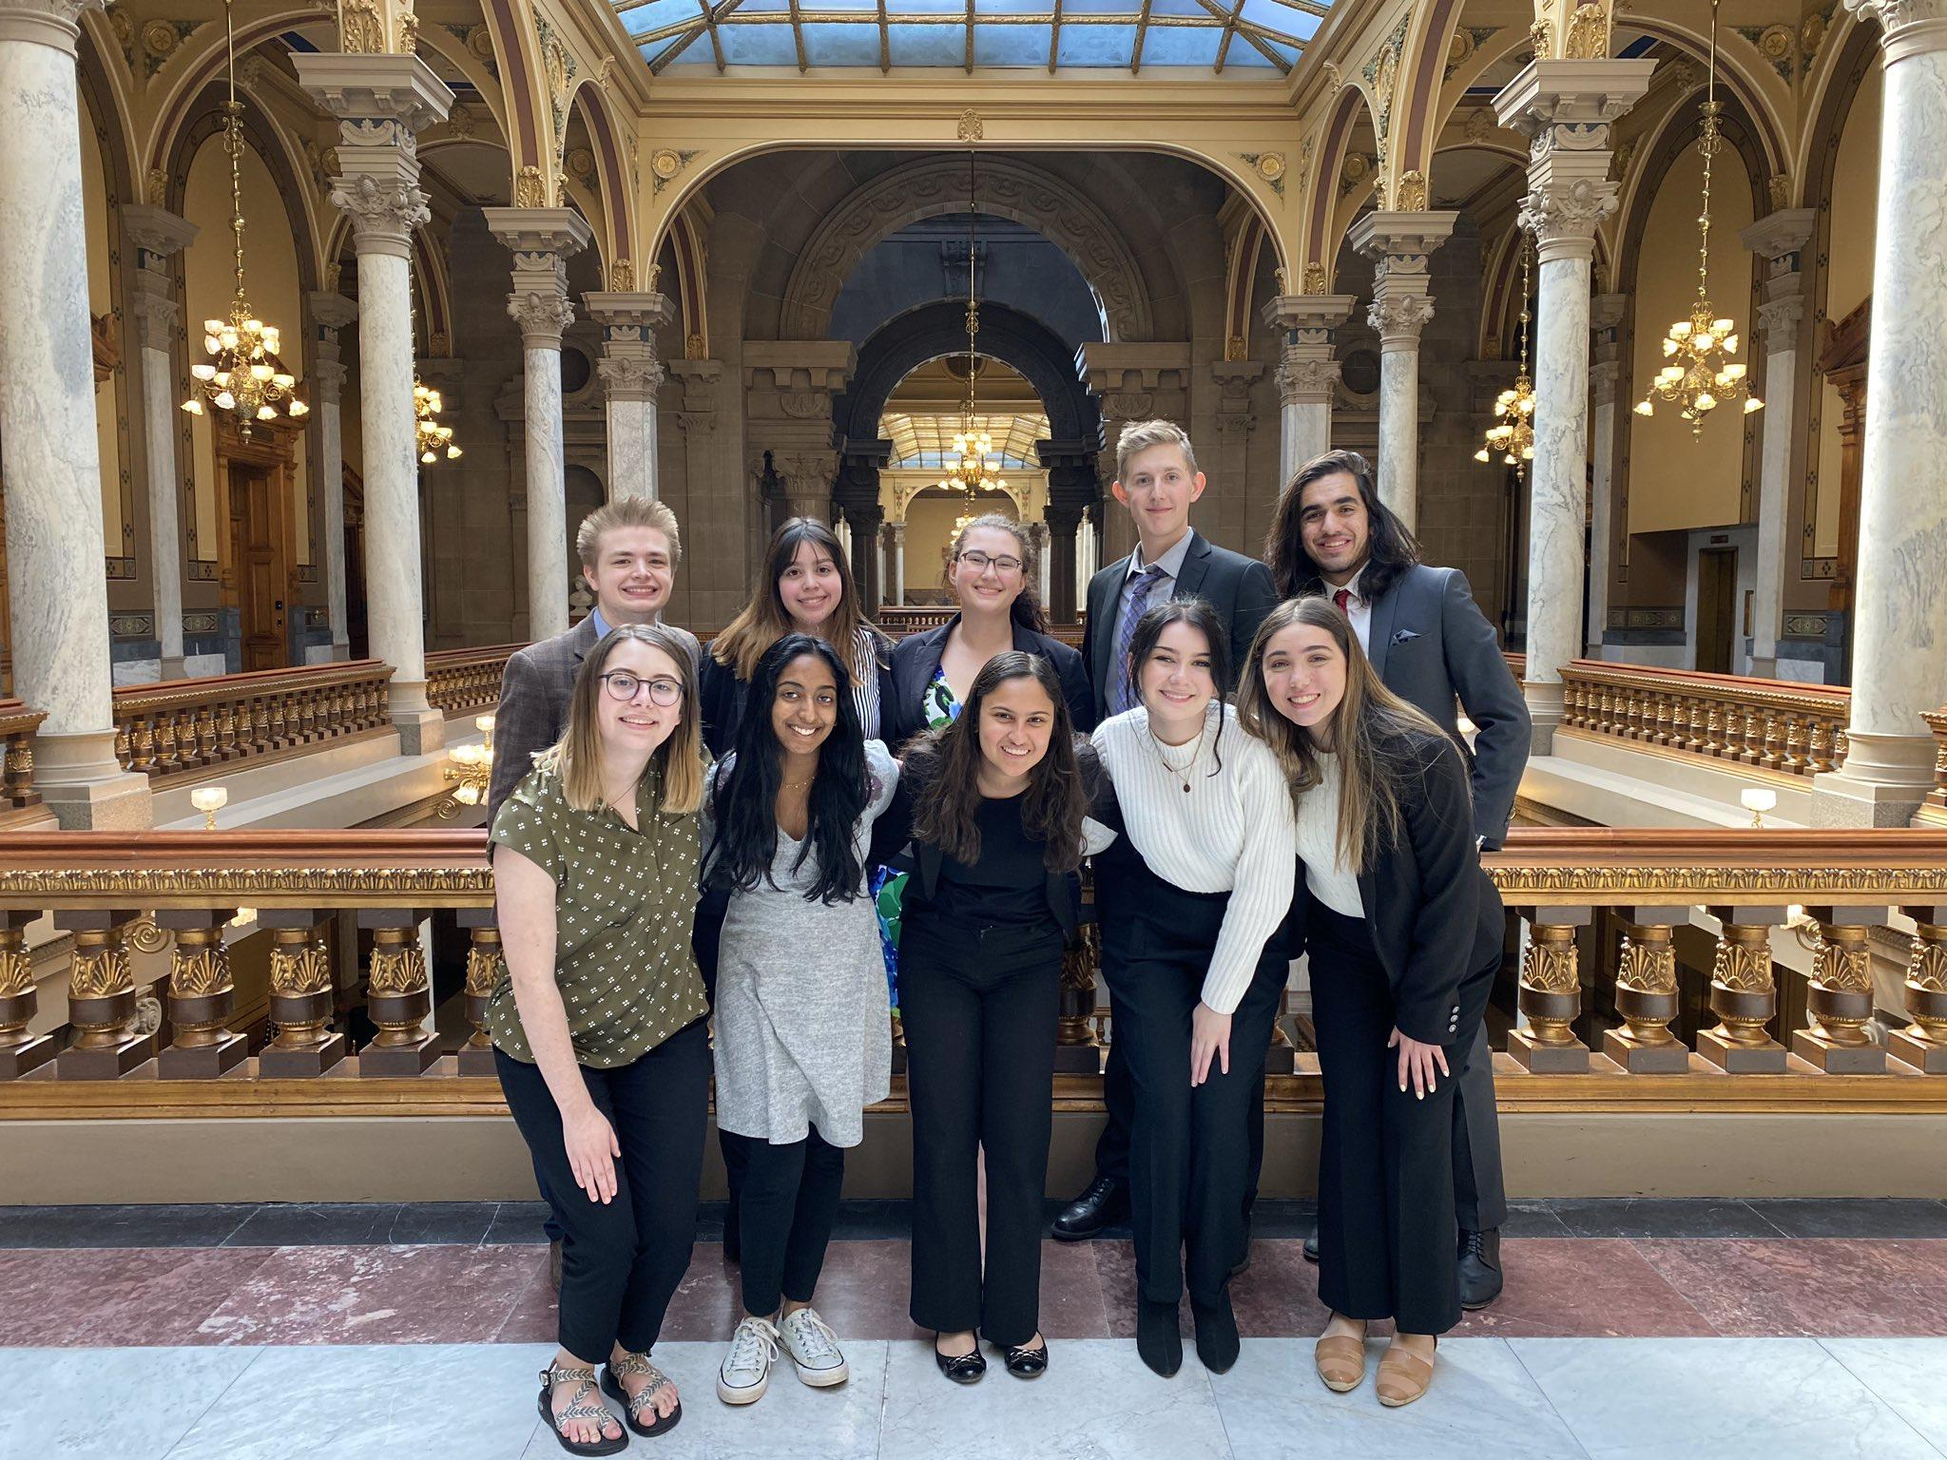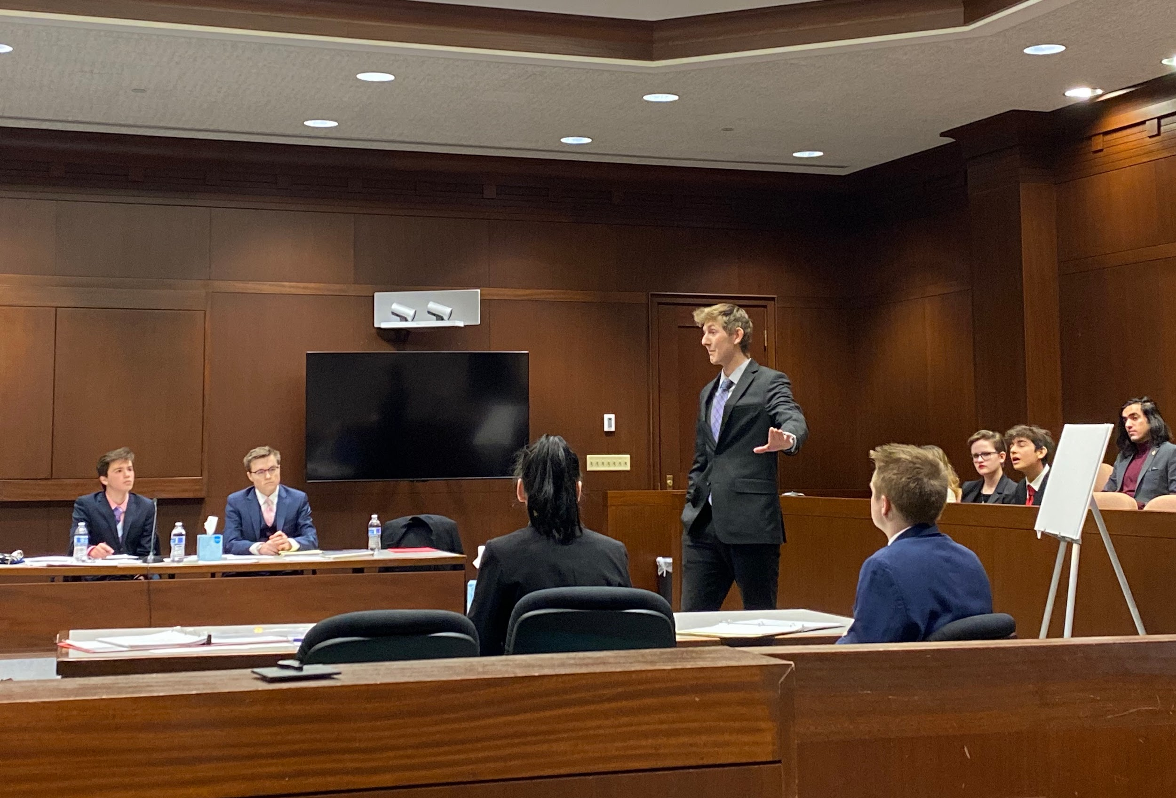

**Social Media:**  [@HerrMathias](https://twitter.com/HerrMathias)

**Membership Requirements:** Must participate in tryouts. If you make the team, there is a (roughly) $25-40 activity fee. Contact Mr. Mathias with any questions!

**Club Meeting Info**: TBD

MODEL UNITED NATIONS

**Sponsor(s):** Jennifer Gabbard, [jgabbard@hse.k12.in.us](mailto:jgabbard@hse.k12.in.us) / Jenna Pritchard, [jpritchard@hse.k12.in.us](mailto:jpritchard@hse.k12.in.us)

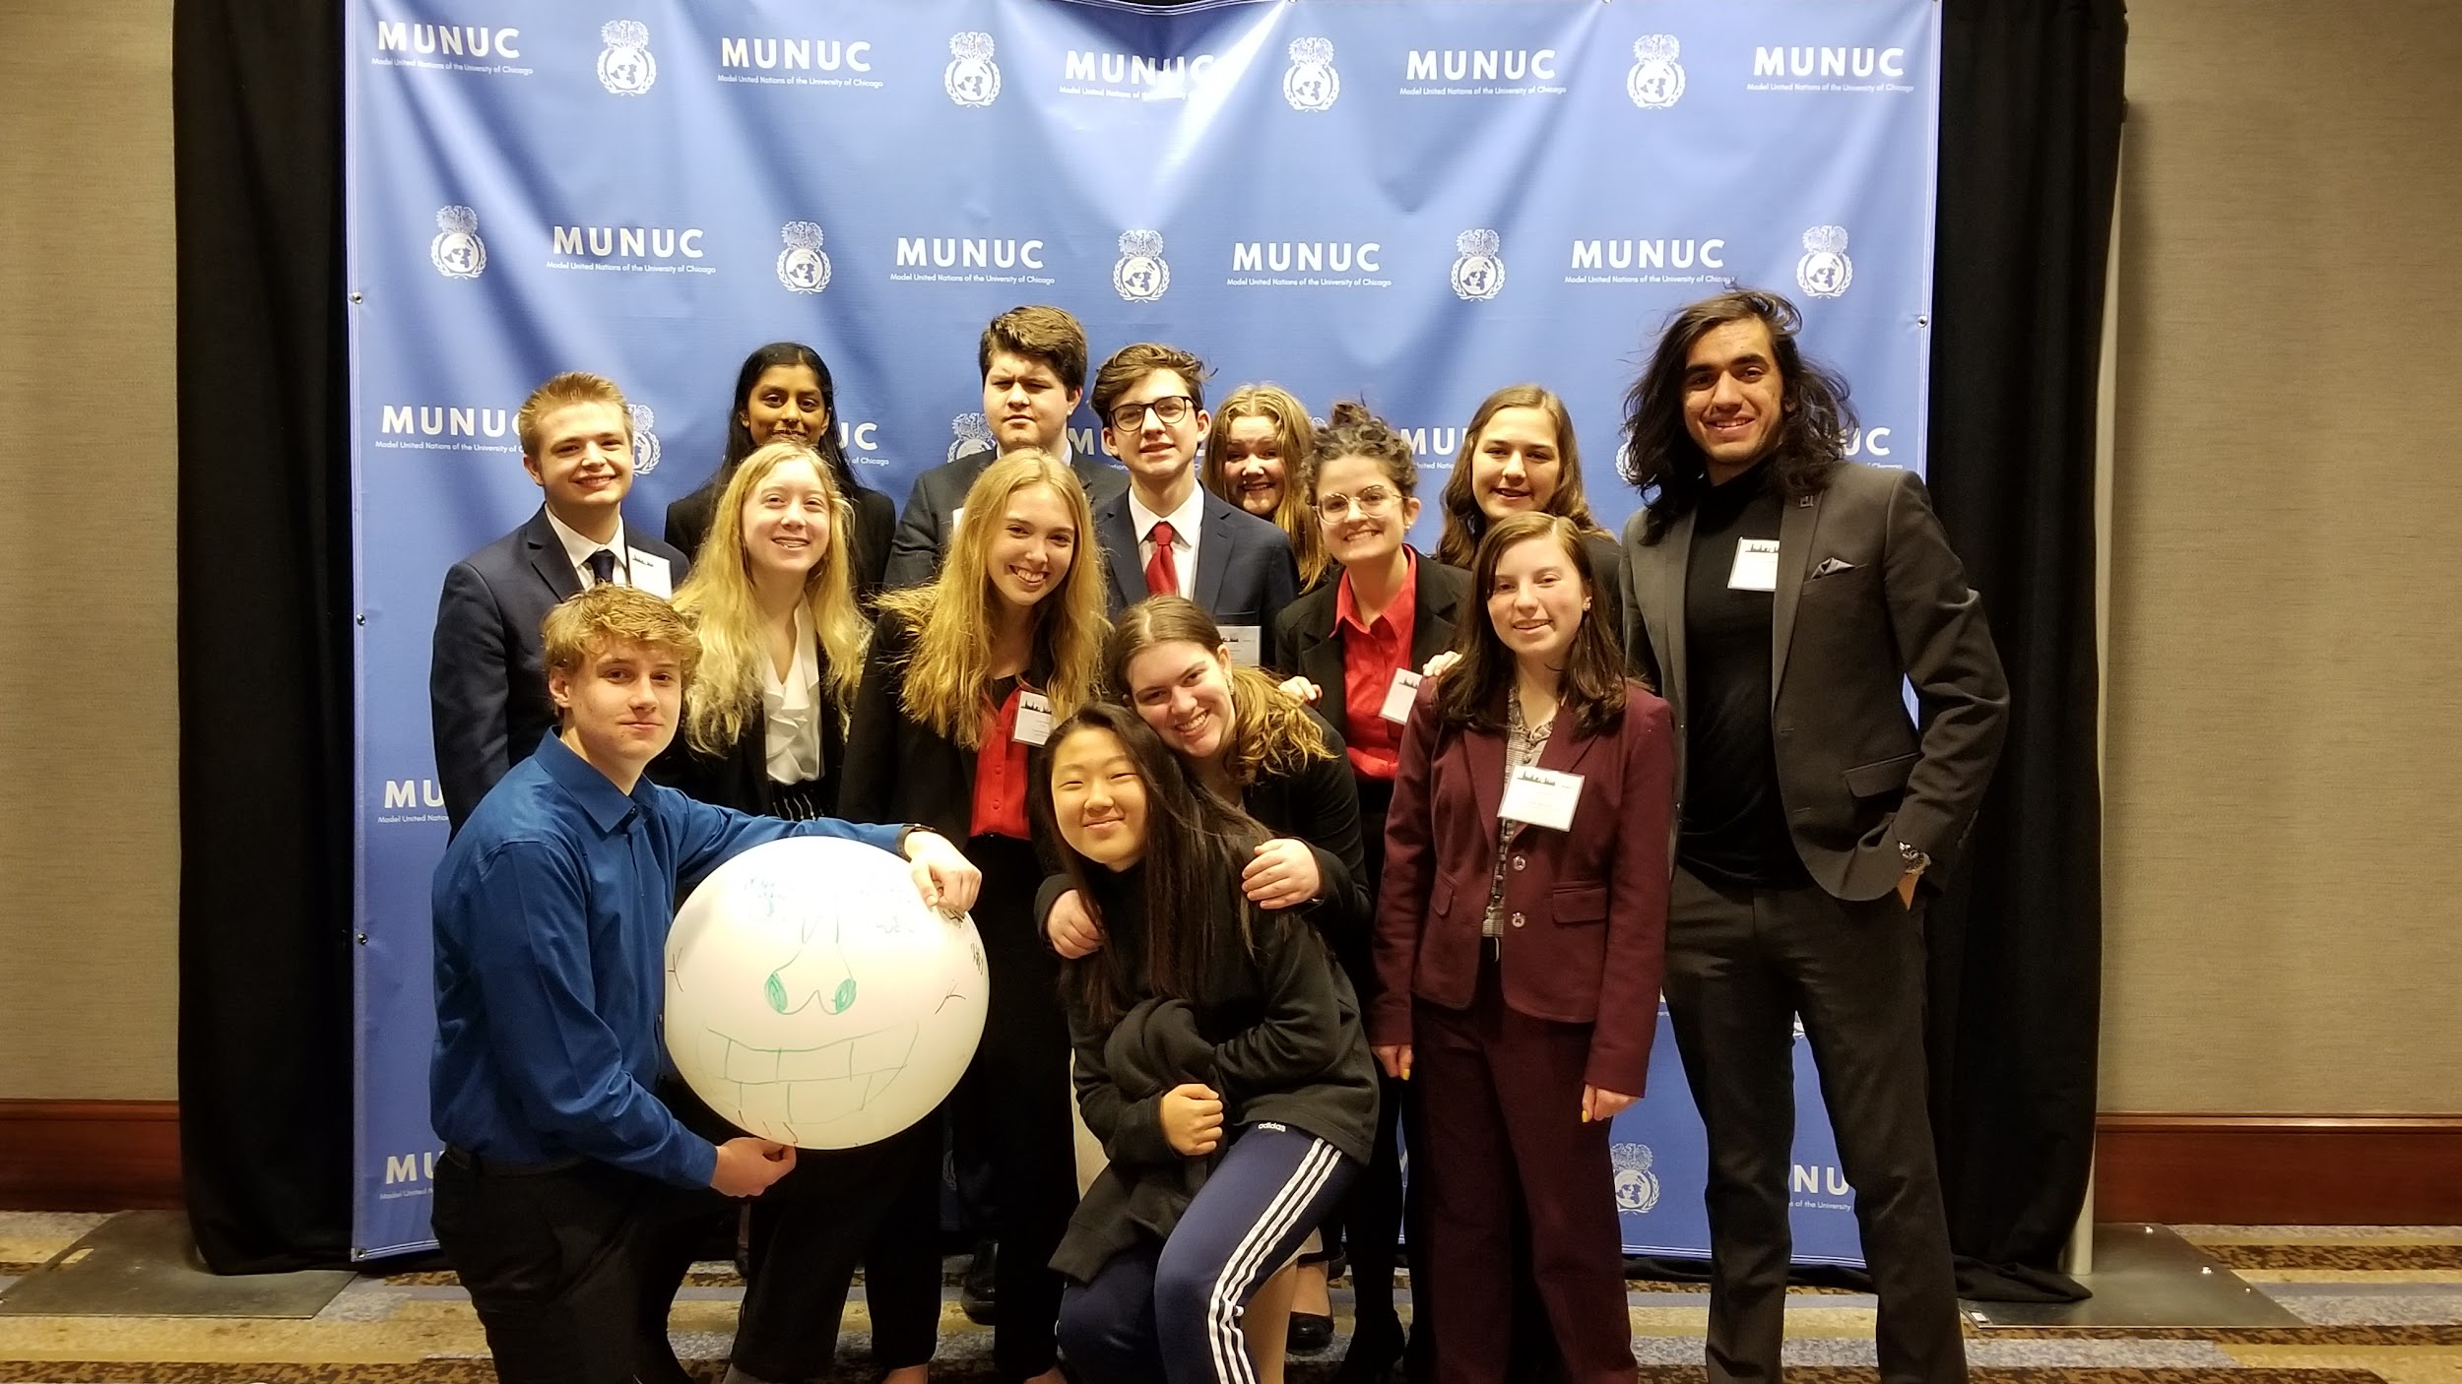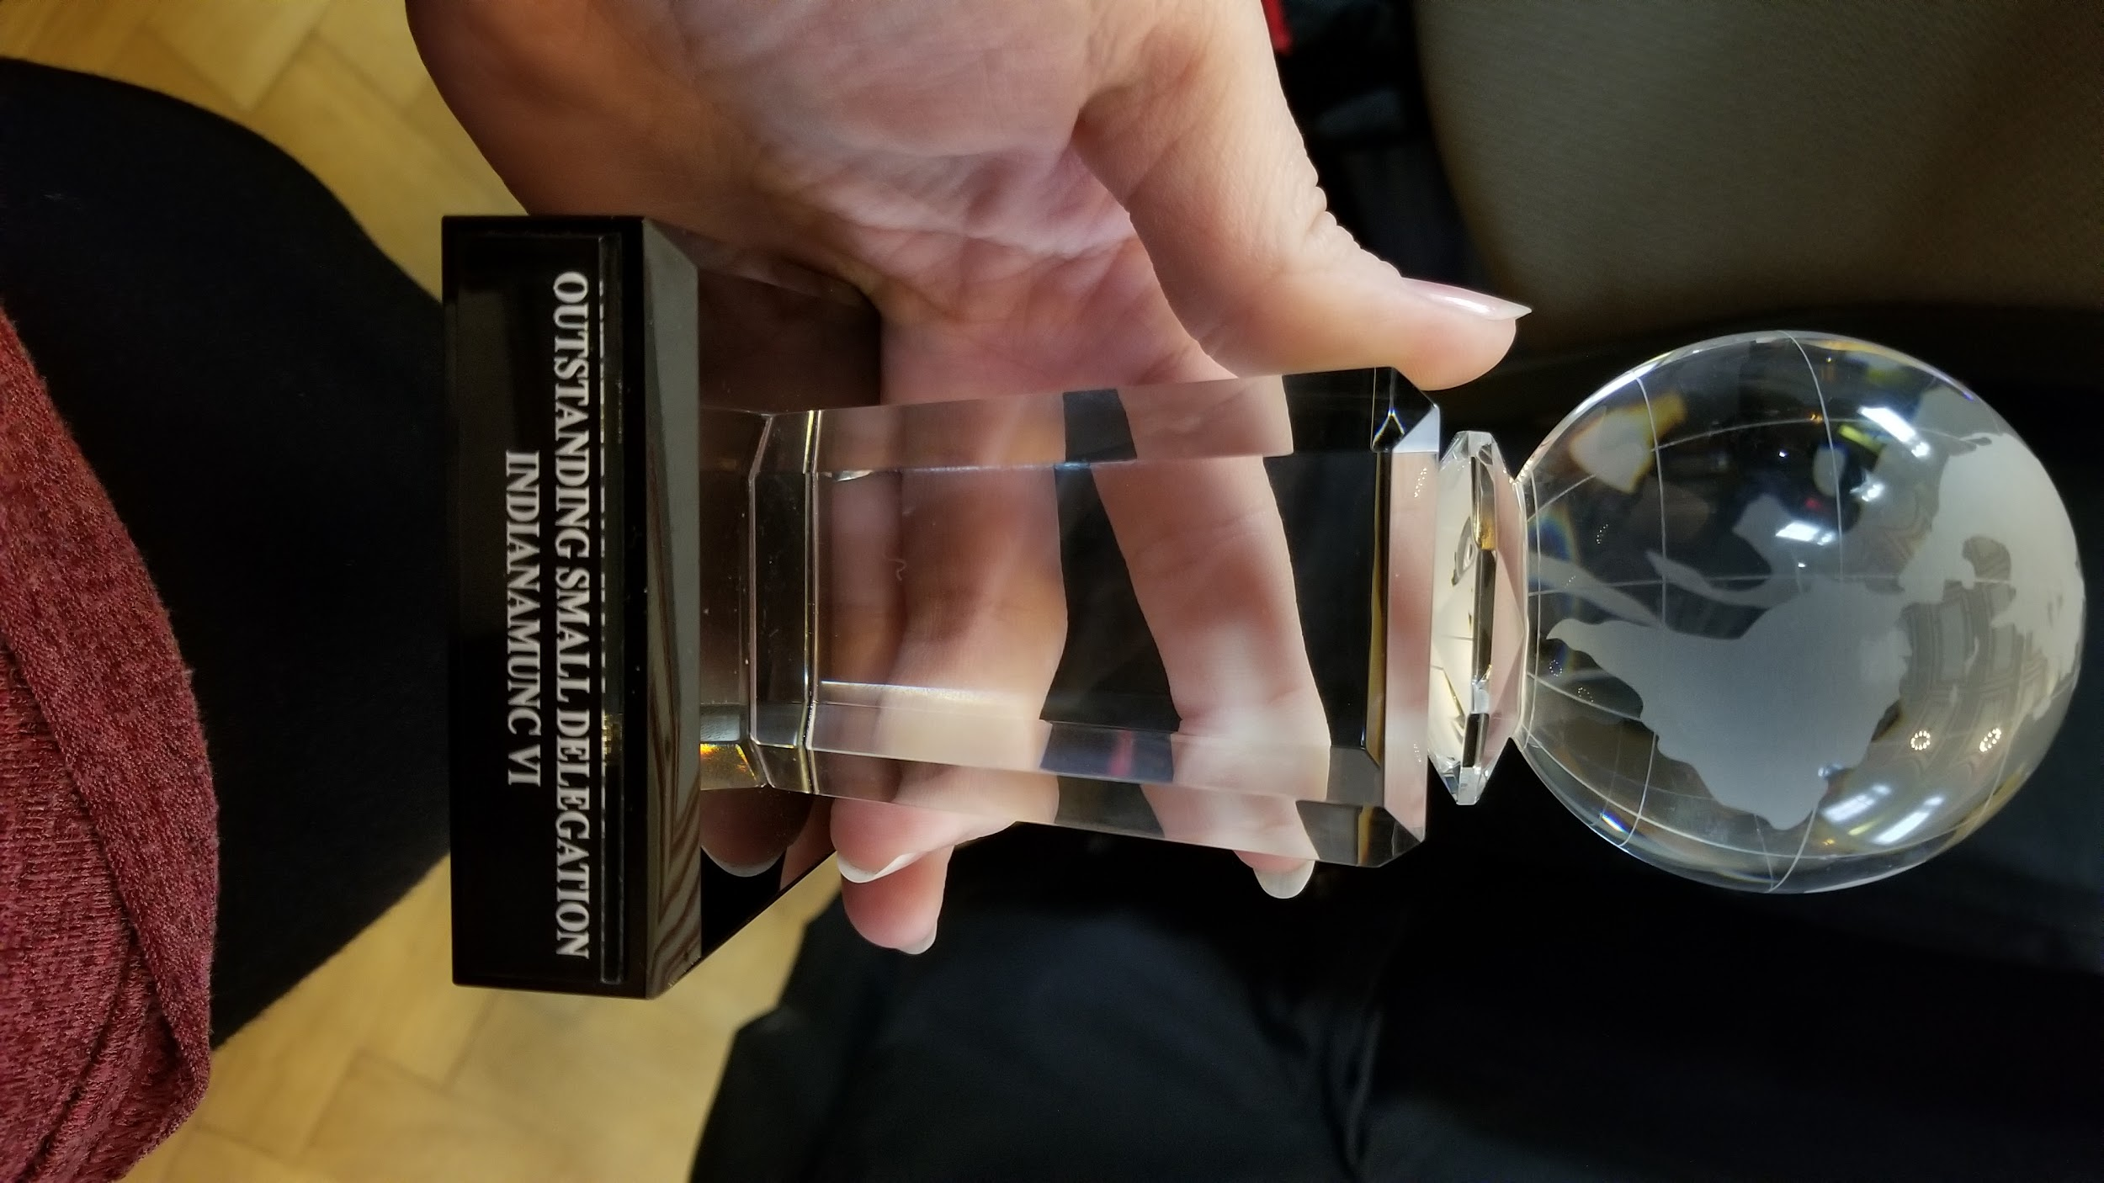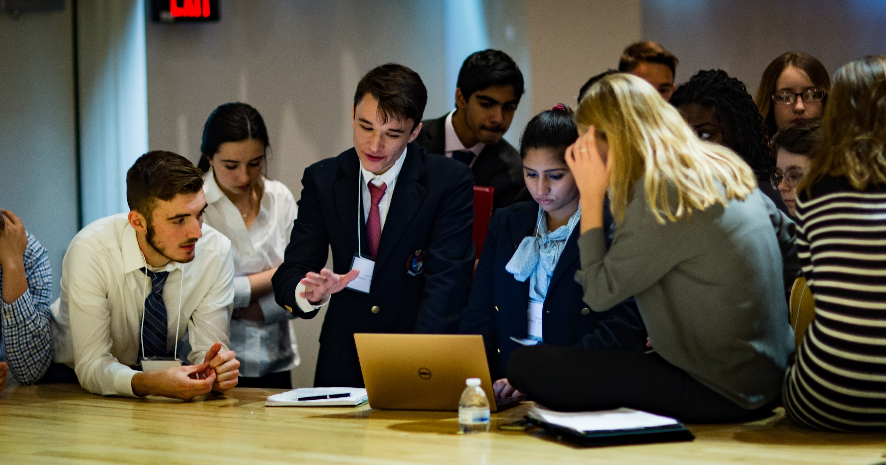

**Description:** Model United Nations is an opportunity for students to apply their knowledge and skills in a real-world situation. Students learn and become “delegates” to various committees within the United Nations and then role-play through the procedures, debates, and negotiations that take place during UN meetings. During regular meetings and at optional competitions (both local and out-of-state), delegates work together to develop resolutions that solve a particular problem or provide new solutions to existing concerns. The skills necessary to do well in Model UN come from all disciplines, and no previous experience is required. Students share one common trait: they care and/or want to know more about the world around them. [Want to know even more? See here.](https://bestdelegate.com/what-is-model-united-nations/)

**Social Media:** Remind - text @FHSMUN to 81010 / Twitter - @FishersMUN / Instagram - fishersmun

**Membership Requirements:** All are welcome! Attendance is flexible for those also participating in other athletic or extracurricular activities.

**Club Meeting Info**: Callout meeting is Tuesday, August 29th, at 3pm in the LGI room (near FH1). **We will continue to meet every Tuesday in the LGI room from 3:00-4:00 pm**. Prior attendance isn’t necessary--join us!

MUSIC & SOUND RECORDING CLUB

**Sponsor(s):** Ray Masterson, [rmasterson@hse.k12.in.us](mailto:rmasterson@hse.k12.in.us)

**Description:** Write, record and enjoy music.

**Membership Requirements:** Some recording knowledge preferred, but none required.

**Social:** Remind**:** Text @MSR24 to 81010 - Instagram- @FHSmusicsound

**Club Meeting Info**: Red Day Wednesdays 3PM - 4:30PM

MUSLIM STUDENT ASSOCIATION (MSA)

**Sponsor(s):** Matt Bockenfeld, [mbockenfeld@hse.k12.in.us](mailto:mbockenfeld@hse.k12.in.us)

**Description:** The MSA is an organization devoted to activating the Muslim students in FHS via service and activism, educating both Muslims and people of other faiths about Islam, and cultivating a better environment for students.

**Membership Requirements:** All are welcome!

**Club Meeting Info**: Meet every other Wednesday (starting September 1) in B230

NATIONAL HONOR SOCIETY

**Sponsor(s):** Beth Schulhof, [eschulhof@hse.k12.in.us](mailto:eschulhof@hse.k12.in.us); Sarah Druelinger, [sdruelinger@hse.k12.in.us](mailto:sdruelinger@hse.k12.in.us)

**Description:** Service is an intricate part of membership in The National Honor Society. Our chapter organizes one service project each semester, runs the annual FHS No Shave November, and sponsors a family. The chapter donates all money raised to different organizations in or around our community every year. This society is only for juniors and seniors. The application process starts in February (for the following year).

**Social Media:** Twitter - @fishersnhs / Instagram - @FishersNHS / NHS Canvas Board

**Membership Requirements:**

Application Process - Interested students may pick up an NHS application packet in the main office, CCA Office, NHS advisor classrooms, or from the NHS bulletin board located in the lower C hall, late February/beginning of March.

Membership is for the following school year so only sophomores and juniors may apply. GPA - Cumulative 3.33 or higher on 4.0 scale. Minimum of 3 leadership positions AND/OR membership of extra-curricular activities. Proof of at least 10 hours of community service within the Fishers area beginning freshman year to time of application. Four teacher recommendations.

Members, once inducted, are required to complete at least 7 hours of community service each semester, participate in all NHS-sponsored events, and maintain a 3.33 GPA or higher.

ORCHESTRA CLUB

**Sponsor(s):** Susan Lyons, [slyons@hse.k12.in.us](mailto:slyons@hse.k12.in.us), Julie Armey, [jarmey@hse.k12.in.us](mailto:jarmey@hse.k12.in.us)

**Description:** This club accepts anyone that plays an orchestral instrument (winds and percussion included). We will perform for a nursing home in December, and with other students from the district in the spring. The club has the potential to have masterclasses and technique lessons. The club will also have social events.

**Social Media:** Remind - @

**Membership Requirements:** Must currently play an orchestral instrumental (strings, winds, or percussion)

**Club Meeting Info**: Selected Mondays from 3:15 to 4:00pm

PEP BAND

**Sponsor(s):** Chad Kohler([ckohler@hse.k12.in.us](mailto:ckohler@hse.k12.in.us)), Elijah Gardner (egardner@hse.k12.in.us)

**Description:** Pep Band plays at 10-14 varsity basketball home games each year. Any band student can join to play high-energy music!

**Club Meeting Info**: Basketball season (selected home games November-March)

**Social Media:** Remind - @fishpep / Instagram - @fishersband

**Membership Requirements:** Must be available for all pep band games. Must be enrolled in a curricular band class at FHS. Drum set and bass guitar by audition.

PING PONG CLUB

**Sponsor(s):** Sarah Druelinger, [sdruelinger@hse.k12.in.us](mailto:sdruelinger@hse.k12.in.us)

**Description:** An easy going opportunity to play ping pong!

**Club Meeting Info**: Upstairs H-meetings TBD

**Social Media:** TBD

**Membership Requirements:** Any student may attend ping pong club on any meeting day!

PODCAST CLUB

**Sponsor(s):** Ray Masterson, [rmasterson@hse.k12.in.us](mailto:rmasterson@hse.k12.in.us)

**Description:** Listen to, enjoy and learn to make podcasts.

**Social Media:** Remind**-** Text @PodClub24 to 81010 - Instagram- @FHSmusicsound

**Membership Requirements:** Everyone who loves podcasts is welcome.

**Club Meeting Info**: Sliver Day Wednesdays 3PM - 4:30PM

POKER CLUB

**Sponsor(s):** Bill Buckman, [mbuckman@hse.k12.in.us](mailto:mbuckman@hse.k12.in.us)

**Description:** This club will meet Wednesday mornings (see dates below) to play variations of the traditional game, Poker. In Poker club, **no gambling is involved**. Instead, members will play recreationally, with allergy-safe candy as a prize. In the first few meetings of the year, we will lead instructive games that will teach everyone the game, and then we will evolve into more of a competitive structure. The poker chips, playing cards, etc. will be supplied by the two presidents of the club.

**Social Media:** Text @fhspoker to 81010

**Membership Requirements:** No experience necessary, all are welcome

**Club Meeting Info**: Meeting dates: 9/13, 9/27, 10/11, 10/25, 11/8, 12/6 and 12/20

7:30-8:15 AM Room B111

PUNJABI CULTURE CLUB (PCC)

**Sponsor(s):** Matt Stahl, [mstahl@hse.k12.in.us](mailto:mstahl@hse.k12.in.us)

**Description:** TBD

**Membership Requirements:** TBD

**Club Meeting Info**: TBD

RILEY DANCE MARATHON

**Sponsor(s):** Danielle Goodwin, [dgoodwin@hse.k12.in.us](mailto:dgoodwin@hse.k12.in.us); Natalie Thomen, [nthomen@hse.k12.in.us](mailto:nthomen@hse.k12.in.us)

**Description:** Fishers Dance Marathon is a student driven organization, focusing on yearlong fundraising that benefits Riley Hospital for Children in Indianapolis. This organization was started in 2008, raising $6,400 to 2019, when we raised over $114,000. With all proceeds specifically going towards children's cancer research. The year culminates in a 6-hour dance marathon event, held in the CCA of Fishers High School. This is a magical, emotional and life-changing night for the student body, community and riley families. They get together to share stories, laughter and tears. Dances will be taught, awareness will be raised and the understanding of empathy and philanthropy will be present “For The Kids” at Riley Hospital.

**Social Media:** Instagram and Twitter = @fhs_dm // Facebook = Fishers Dance Marathon.

**Canvas page:** If you are *not* on our FHS Riley Dance Marathon Canvas page please email Mrs. Thomen with your name and school email address.

**Membership Requirements:** $10 membership fee for this school year and actively participate in volunteer opportunities throughout the year

**Club Meeting Info**: Meet before school throughout the year - look at our Canvas/Remind 101s/Social Media for specific dates and upcoming events

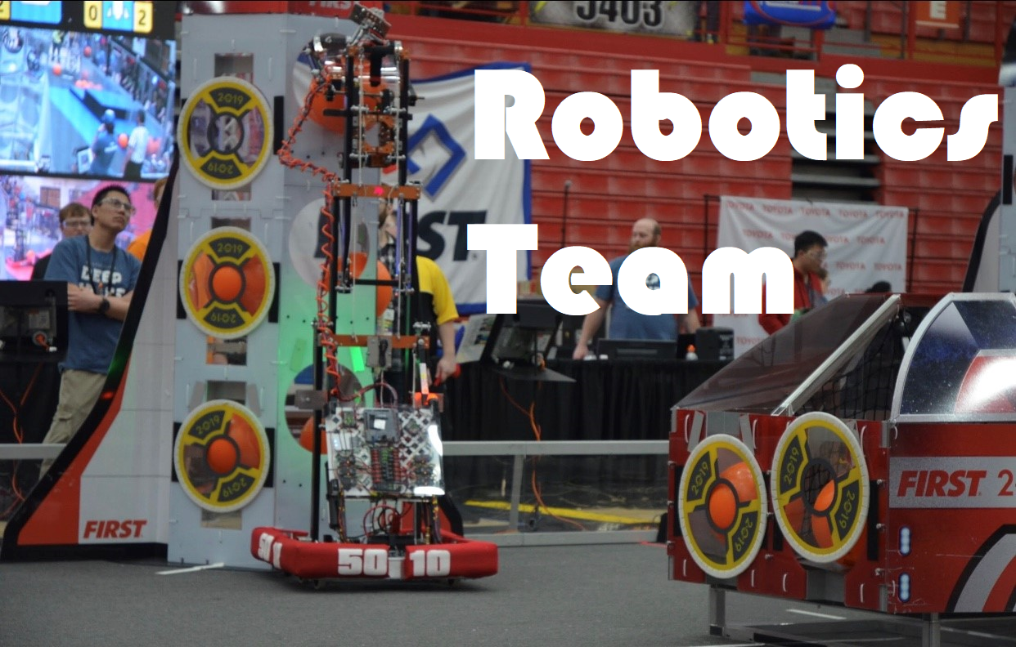

ROBOTICS TEAM

**Sponsor(s):** Jeff Fronius, [jfronius@hse.k12.in.us](mailto:jfronius@hse.k12.in.us)

**Description:** The robotics team competes in the FIRST Robotics League. The team works with mentors to design, build, and compete with a robot. The team mentors students for the following skills: mechanical building, electrical, marketing, computer programming, strategy, and leadership. The team meets two days per week during the non-competition season, and six days a week between January and April. Many outreach events also occur throughout the year. A majority of our students receive college scholarships in a technical field. **Watch our team video** [here](https://www.youtube.com/watch?v=bVAS2exQIwU&feature=youtu.be).

**Social Media:** Website - tigerdynasty.org / Twitter - @FRC5010

**Membership Requirements:** Open to all students who maintain good grades and can attend regularly. There is a fee to join the team.

**Call out meetings**: August 16th, and August 23rd, in room C101.

ROCK CLIMBING CLUB

**Sponsor(s):** Monica Jordan, [mrjordan@hse.k12.in.us](mailto:mrjordan@hse.k12.in.us)

**Description:** This club is for students who have a passion for rock climbing AND students who are interested in learning how to rock climb! The group meets at Climb Time Indy on a bi-weekly basis on Wednesdays from 6:00 to 8:00 PM beginning 09/20/2023. The group gets a school club discount ($10).

**Membership Requirements:** There is a required waiver that Climb Time Indy will have parents fill out on their website; additionally, there is an HSE Schools waiver that students must complete as well. Club participants should bring $10 each time they want to climb; that fee includes shoe and harness rental, as well as a climbing pass for the evening.

**Club Meeting Info**: The group meets at Climb Time Indy on a bi-weekly basis on Wednesdays from 6:00 to 8:00 PM beginning 09/20/2023. Call Out Meeting is 09/13/2023 in FHS Library.

RUGBY (GIRLS)

**Sponsor(s):** Austin, Antoni, [austinantoni@gmail.com](mailto:austinantoni@gmail.com)

**Description:** TBD

**Membership Requirements:** TBD

**Club Meeting Info**: TBD

SCHOOL OF ROCK

**Sponsor(s):** Mike Czech, [mczech@hse.k12.in.us](mailto:mczech@hse.k12.in.us)

**Description:** This club will be a place for students to bring in their guitar and musical gear to jam and play music together.

**Membership Requirements:** Participants should bring their own musical instruments & equipment

**Club Meeting Info**: TBD

SCIENCE OLYMPIAD

**Sponsor(s):** Dan Mach, [dmach@hse.k12.in.us](mailto:dmach@hse.k12.in.us) / Summer Noyes [snoyes@hse.k12.in.us](mailto:snoyes@hse.k12.in.us)

**Description:** Science Olympiad is a team competition in which students compete in 23 “events” pertaining to various scientific disciplines, including earth science, biology, chemistry, physics, and engineering.

**Membership Requirements:** $75 dues, off-campus competitions, mandatory meetings, time required to build and practice for events.

**Club Meeting Info**: TBD

SCRABBLE CLUB

**Sponsor(s):** Beth Schulhof [eschulhof@hse.k12.in.us](mailto:eschulhof@hse.k12.in.us)

**Description:** Calling all “word nerds”! All are welcome to join Scrabble club to test your knowledge of vocabulary. The club meets every Wednesday from 7:30-8:15am in H213. Please contact Mrs. Schulhof if interested.

**Social Media:** @fhsscrabbleclub on Instagram

**Membership Requirements:** None

**Club Meeting Info**: Wednesdays 7:30-8:15am H213

SKI CLUB

**Sponsor(s):** Ben Beasley, [bbeasley@hse.k12.in.us](mailto:bbeasley@hse.k12.in.us)

**Description:** This club is open to all students (experienced and non-experienced skiers are welcome). The club will meet in November to establish a schedule for the season. We ski four times per year at Perfect North slopes starting in January.

**Membership Requirements:** Dues change seasonally; the average cost is $290 and includes a lift ticket, charter bus transportation, and ski rentals.

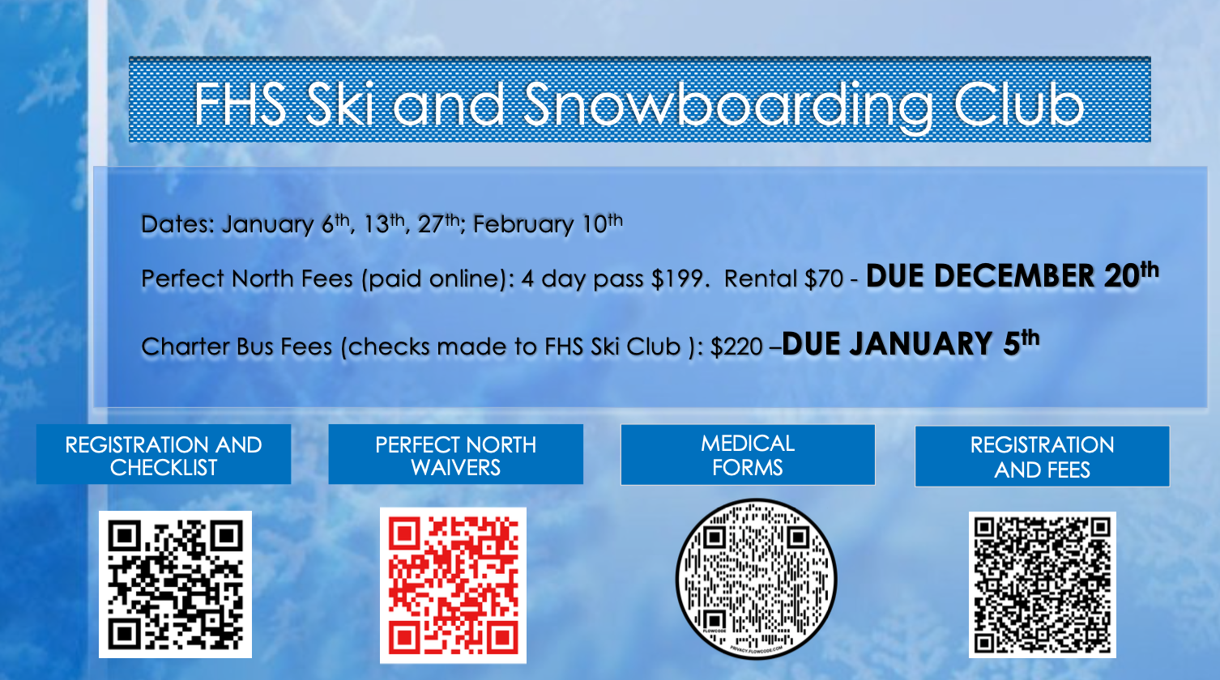

SPANISH CLUB

**Sponsor(s):** Stephanie Gutting, [sgutting@hse.k12.in.us](mailto:sgutting@hse.k12.in.us) / Michelle Helmkamp, [mhelmkamp@hse.k12.in.us](mailto:mhelmkamp@hse.k12.in.us)

**Description:** ¡Olé! Join Spanish Club! Normally, we take field trips to restaurants, cultural festivals, and more. We watch movies in Spanish, celebrate Hispanic holidays, and we would love to have you join us!

**Social Media:** Remind: text @FHSspan21 to 81010

**Membership Requirements:** $5 membership dues (collected at first meeting); T-shirts and food @ restaurants not included in dues.

**Club Meeting Info**: TBD

SPEECH & DEBATE TEAM

**Sponsor(s):** Bob Hinshaw, [rhinshaw@hse.k12.in.us](mailto:rhinshaw@hse.k12.in.us)

**Description:** The Fishers Speech & Debate team competes in public speaking tournaments throughout the state and on the national circuit. Students can compete in theatrical performances, broadcasting, platform speaking, and multiple types of debate.

**Social Media:** Instagram @fishersspeech / Website: [www.fhsspeech.com](http://www.fhsspeech.com)

**Membership Requirements:** Open to all; flexible practice schedule with weekly practice expectation; tournaments on Saturdays. Debate season runs from October to January; Speech season runs from November to March.

**How to Stay in Touch with the Team:** [www.fhsspeech.com](http://www.fhsspeech.com)

**Club Meeting Info**: Built around student schedules— we can accommodate almost all conflicts

SPORTS TRADING CARD CLUB

**Sponsor(s):** Ryan Harris, [rharris@hse.k12.in.us](mailto:rharris@hse.k12.in.us)

**Description:** Open to anyone with a passion for sports trading cards. This club will meet to discuss and share knowledge of the hobby and business of Sports Trading Cards.

**Social Media:** TBD

**Membership Requirements:** TBD

**Meeting Schedule:** TBD

STUDENT ALLIANCE FOR EQUITY (S.A.F.E.)

**Sponsor(s):** Michelle Greco [mgreco@hse.k12.in.us](mailto:mgreco@hse.k12.in.us), Renee Isom, [risom@hse.k12.in.us](mailto:risom@hse.k12.in.us)

**Description:** This club is for students who wish to become **allies** with historically marginalized groups. We will work together to engage in open dialogue and action to undo racism, stereotypes, bias, and oppression.

**Social Media:** Remind= @fhsafe to 81010; Instagram- @safeatfhs

**Club Meeting Info**: Every other Tuesday in the library- join Remind or follow social media for more information.

STUDENT GOVERNMENT

**Sponsor(s):** Jennifer Pope ([jpope@hse.k12.in.us](mailto:jpope@hse.k12.in.us)), Lori Kixmiller ([lkixmiller@hse.k12.in.us](mailto:lkixmiller@hse.k12.in.us)), and Matt Bockenfeld ([mbockenfeld@hse.k12.in.us](mailto:mbockenfeld@hse.k12.in.us))

**Description:** Student Government is the place to be to get involved in all things FHS. From organizing Homecoming week and Riley week to the Pasta Bowl, this club will get you locked in on all the major service and school spirit events that FHS has to offer. [Check out this video and meet your Student Body Officers!](https://youtu.be/DLIABkcfBw0)

**Social Media:** Instagram - @fhs_studentbody / Remind: @ag4gk8

**Membership Requirements:** Involvement in at least 3 FHS activities per school year

**Meeting Schedule:** Usually monthly; announced via announcements & Remind

STUDENT ORGAN DONATION ADVOCATES (SODA)

**Sponsor(s):** Terri Hamilton, [thamilton@hse.k12.in.us](mailto:thamilton@hse.k12.in.us)

**Description:** SODA is a national organization and is supported by Indiana Donor Network. SODA’s main goal is organ donation awareness to students, helping them decide if organ donation is a good fit for them and/or their family. Here is link to the website: <https://www.sodanational.org/>

**Club Meeting Info**: First Red Tuesday of the Month, beginning September 5th. This group will meet after school in Room B136

STUDENTS IN ACTION

**Sponsor(s):** Beth Carson, [acarson@hse.k12.in.us](mailto:acarson@hse.k12.in.us)

**Description:** Students in Action empowers students to think big, choose or create their own public service projects, engage the entire school and broader communities, and create maximum impact and sustainable change.

**Social Media:** Twitter - @FishersSIA / Website: [https://fisherssia.weebly.com](https://fishersstudentsinaction.weebly.com)

**Membership Requirements:** $20 dues; participation in service projects

**Club Meeting Info**: TBD

TECH CREW

**Sponsor(s):** Andy Smith, [asmith@hse.12.in.us](mailto:asmith@hse.12.in.us)

**Description:** Tech crew is a group of people that help build scenery and run productions in the auditorium.

**Social Media:** <https://www.theatre-fishers.com/>

**Membership Requirements:** Basic tool skills and some construction/theatre knowledge

**Club Meeting Info**: Tech crew will meet Tuesdays and Tursdays (beginning date TBD)

TECHNOLOGY STUDENT ASSOCIATION (TSA)

**Sponsor(s):** Brigham French, [bfrench@hse.k12.in.us](mailto:bfrench@hse.k12.in.us)

**Description:** TSA is a national student organization dedicated to promoting skills in science, technology, engineering, and mathematics, as well as business education. FHS will have an official chapter of TSA, giving students interested in these fields an opportunity to enhance their learning and compete at the state conference annually.

**Social Media:** TBD

**Membership Requirements:** TBD

**Club Meeting Info**: TBD

TIGER AMBASSADORS

**Sponsor(s):** Matt Swaim, [mswaim@hse.k12.in.us](mailto:mswaim@hse.k12.in.us)

**Description:** Tiger Ambassadors is a student-run organization that helps new students feel welcome at FHS. Ambassadors are matched with new students to help these students make a positive connection at FHS. We want to make new students feel welcome and to make FHS an inclusive environment.

**Social Media:** Instagram @fhstigeramb_

**Membership Requirements:** Be willing to help and assist new students, as matched. Attend Tiger Ambassador events.

**Club Meeting Info**: Every other Tuesday in the LGI

TIGER LEADERS

**Sponsor(s):** Braden Tribolet, [btribolet@hse.k12.in.us](mailto:btribolet@hse.k12.in.us)

**Description:** Tiger Leaders aims to create a more positive student experience at Fishers High School through student engagement and school spirit. Tiger Leaders look to create experiences that benefit the school as well as advertising the events at the school. Additionally, Tiger Leaders help build upon the student body connection and look to attend and be involved in all school events.

**Social Media:** TBD

**Membership Requirements:** Be passionate about the school and providing a positive experience for each student at Fishers. All are welcome!

**Club Meeting Info**: Every Monday morning at 7:30am in H136

WARHAMMER 40000 CLUB

**Sponsor(s):** Steven Curtis, [scurtis@hse.k12.in.us](mailto:scurtis@hse.k12.in.us)

**Description:** The Warhammer 40000 Club is a branch of the Dungeons & Dragons (D&D) Club, where members will play and learn more about the game. The club will meet at the same time as D&D. The games will consist of multiple people that have already started an army of 500+ points and have some experience with the game.

**Social Media:** TBD

**Membership Requirements:** TBD

**Club Meeting Info**: TBD

YOGA CLUB

**Sponsor(s):** Erin Knapp, [eknapp@hse.k12.in.us](mailto:eknapp@hse.k12.in.us)

**Description: Yoga Club is an opportunity for students to learn basic yoga poses, breathing techniques, and mindfulness practices to help manage stress, improve emotional regulation, enhance concentration, increase self-awareness, and develop strength & flexibility.** NO EXPERIENCE NECESSARY!

**Club Meeting Info**: <https://docs.google.com/spreadsheets/d/194ocGBWvLEfPE0F081XlKtvpQtYOmXx6bCR65DDsF4E/edit?usp=sharing>

YOUNG REPUBLICANS CLUB

**Sponsor(s):** Chris Edwards, [cedwards@hse.k12.in.us](mailto:cedwards@hse.k12.in.us)

**Description:** Young Republicans is a club that explores American politics and encourages community service. This club also gives students the chance to discover their beliefs and learn about our government.

**Social Media:** *Instagram*: fishers_republicans_ *Remind*: text @fhsyoungr to 81010

**Membership Requirements:** This club is open to all students, regardless of political background or beliefs!

**Club Meeting Info**: Monthly meetings, with some outside school activities.